Session 5 - 1

import java.util.Scanner;

class MyCalculator {
public long power(int n, int p) throws Exception {
if (n < 0 || p < 0) {
throw new Exception("n or p should not be negative.");
}
if (n == 0 && p == 0) {
throw new Exception("n and p should not be zero.");
}
return (long) Math.pow(n, p);
}
}

public class Solution {
public static final MyCalculator my_calculator = new MyCalculator();
public static final Scanner in = new Scanner(System.in);

public static void main(String[] args) {
while (in.hasNextInt()) {
int n = in.nextInt();
int p = in.nextInt();

try {
System.out.println(my_calculator.power(n, p));
} catch (Exception e) {
System.out.println(e);
}
}
}
}

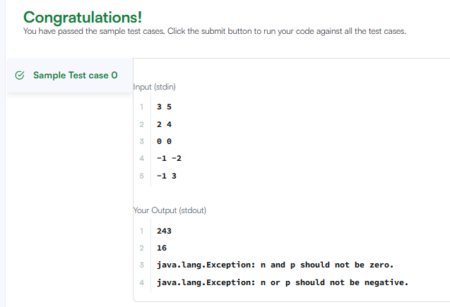

Session 5 - 2

import java.io.*;
import java.util.*;

public class Solution {

public static void main(String[] args) {
Scanner sc = new Scanner(System.in);
try {
int x = sc.nextInt();
int y = sc.nextInt();
System.out.println(x / y);
} catch (InputMismatchException e) {
System.out.println(e.getClass().getName());
} catch (ArithmeticException e) {
System.out.println(e);
} finally {
sc.close();
}
}
}

